Extra Practice Problems for iRAT Oct 8th session
- Calculate the mEq and percentage mg% Na⁺ and K⁻ in the following solution (Na =23, K= 39)
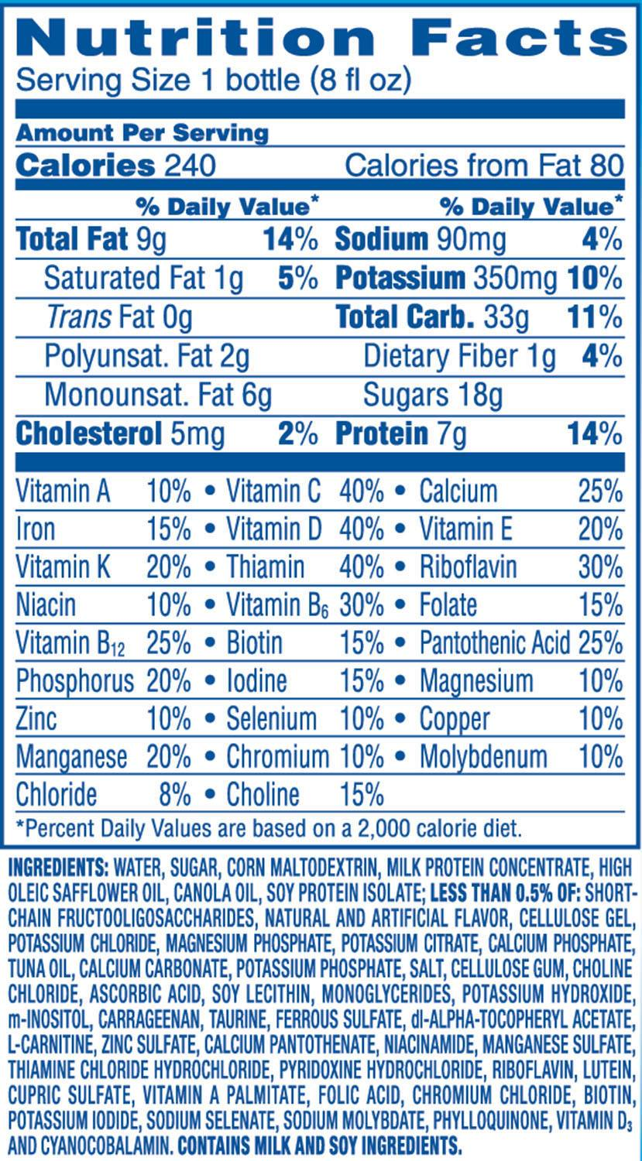

- Pedialyte contains the following per liter
Sodium 45 mEq
Potassium 20 mEq
Chloride 35 mEq
Citrate 30 mEq
Calculate the equivalent quantities of each in milligrams/ tablespoonful
- Calculate the osmolarity of the following solutions
- 0.13 M of urea
- 0.12 M MgCl₂
- 0.2 M of glucose

